

**Project Status Report**



**Project Name:** Project LSC

**Department:** School of Computing and Information Technology

**Focus Area:** Reservation System

**Product/Process:** Reserve Slot for Review Class



**Prepared By:**

|  |  |
| --- | --- |
| **Document Owner(s)** | **Project/Organization Role** |
| Aira Joyce Carpio | Project Manager |
| Danya Balcena | Project Developer |
| Florence Gail Haboc | Project Developer |

**Project Status Report Version Control**

|  |  |  |  |
| --- | --- | --- | --- |
| **Version** | **Date** | **Author** | **Change Description** |
| 1.0 | 08/18/16 | Aira Joyce Carpio  Danya Balcena  Florence Gail Haboc | * Assigning of tasks for 9th Week |
| 1.0 | 08/18/16 | Aira Joyce Carpio  Danya Balcena  Florence Gail Haboc | * Frontend Prototype Interface Design * Frontend databases and forms |
| 1.0 | 08/19/16 | Aira Joyce Carpio  Danya Balcena  Florence Gail Haboc | * Backend databases and forms * Backend prototype interface design |
| 1.0 | 08/22/16 | Aira Joyce Carpio  Danya Balcena  Florence Gail Haboc | * Project Meeting |

**TABLE OF CONTENTS**

1 PROJECT STATUS REPORT PURPOSE 2

2 PROJECT STATUS REPORT TEMPLATE 2

2.1 Project Status Report Details 2

2.2 Project Status Report Template 2

3 PROJECT STATUS REPORT APPROVALS 2

4 APPENDICES 2

4.1 Document Guidelines 2

4.2 Project Status Report Sections Omitted 2

# PROJECT STATUS REPORT PURPOSE

The Project Status Report is a document that Project Managers may use as a means of formal regular reporting on the status of a project to key project stakeholders, including the Steering Committee, Project Sponsor, and Senior Manager. Project Status reports can also use to provide a documented history of the project. This can be applied to strengthen lessons learned and to evaluate, review and learn from how the project succeeded and where it may have had difficulties.

Objectives of effective project status reporting include.

* Improve communication of information within the project and across the organization
* To create a record of the project progress
* Improve organizational support for the project
* To determine the improvement of the project
* Simplify the process of gathering and disseminating project information



# PROJECT STATUS REPORT TEMPLATE

## Project Status Report Details

Loyola Student Center (LSC) is a tutorial and review facility located on Katipunan Avenue. The institution tutors’ student from Kindergarten to Tertiary education. They also offer review programs such as Comprehensive College Entrance Test Review, High School Entrance Test Review, Civil Service Examination Review, Law Aptitude Examination (LAE)/Law School Admission Test (LSAT) Review, and National Medical Admission Test (NMAT) Review etc. Most of the transactions done in LSC such as enrollment is recorded on papers, due to this reason our team aims to provide website and mobile solution which is an Enrollment system for the institution. When students enroll themselves using the online enrollment system, all the information given by the student will be saved to the database so that the institution can easily manage and track all the transactions. In addition, it can also help the students enroll easily using their smartphones or computers.

## Project Status Report Template

|  |  |  |
| --- | --- | --- |
| Project Name | | |
| Prepared By:  Aira Joyce A. Carpio | Date:  08/22/16 | Reporting Period:  08/18/16 to 08/22/16 |
| Project Overall Status:  Project team still doing the frontend interface design, databases and forms using yii2.0. | | |
| Project Summary:  Project team already doing frontend and backend interface design. | | |
| **Milestone Deliverables performance reporting over last period**   |  |  |  |  | | --- | --- | --- | --- | | **Milestone Deliverables** | **Due Date** | **% Completed** | **Deliverable Status** | | Milestone 1 | | | | | | * Assigning of tasks for 8th Week | August 15, 2016 | 100% | On Schedule | | * Frontend Prototype Interface Design | August 11, 2016 | 60% | On Schedule | | * Frontend databases and forms | August 11, 2016 | 60% | On Schedule | | Milestone 2 | | | | | | * Assigning of tasks for 8th Week | August 18, 2016 | 100% | On Schedule | | * Frontend Prototype Interface Design * Frontend databases and forms | August 18, 2016 | 60% | On Schedule | | * Backend databases and forms * Backend prototype interface design | August 19, 2016 | 50% | On Schedule | | | |
|  | | |
| **Milestone Deliverables scheduled for completion over next period**   |  |  |  |  | | --- | --- | --- | --- | | **Milestone Deliverables** | **Due Date** | **% Completed** | **Deliverable Status** | | Milestone 1 | | | | | * Project Meeting | August 22, 2016 | 50% | On Schedule | | * Frontend and Backend Interface design and functionalities | August 22, 2016 | 60% | On Schedule | | * Finalize project requirements | August 25, 2016 | 70% | On Schedule | | Milestone 2 | | | | | * Sysadd2 project presentation | August 25, 2016 | 20% | On Schedule | | * Create Project Schedule for 10th week | August 25, 2016 | 40% | On Schedule | | | |
| **Project impact of milestone success or failure for project remainder**   |  |  | | --- | --- | | The team divides the task every week to each member to submit all the requirements on time. | As the project progresses, the team works together to make the project more successful. | | | |
| **Project** **Budget/Financial Status**   |  |  |  |  | | --- | --- | --- | --- | | **Budget Item** | **Planned Budget** | **Actual Cost** | **Variance/Explanation** | | Transportation | 333 | 370 | Transportation fee for Client meeting | | Transportation | 368 | 380 | Transportation fee for Client meeting | | | |
| **Project Risk Management Status**   |  |  |  |  |  | | --- | --- | --- | --- | --- | | **Risk and Description** | **Risk Chance** | **Risk Impact** | **Risk Priority** | **Change from Last Review** | | The naming conventions in the Database and diagrams were not consistent. | Medium | Medium | High | The errors in the documents were corrected by the project team | | | |
| **Project Issue Management Status**   |  |  |  |  |  | | --- | --- | --- | --- | --- | | **Issue and Description** | **Project Impact** | **Target Due Date** | **Issue Status** | **Issue Resolution** | | The process of review class reservation is not yet finalized. | High | August 22, 2016 | Closed | Project Meeting | | Immediately analyzed and finalized the project requirements | High | June 23, 2016 | Closed | Project Meeting | | | |
| **Project Recommendations**   |  | | --- | | * The Group should consult their adviser and professor more often to ensure that all documents created by the group is precise and includes legitimate information. The group should also communicate with their client more often about the proposed project that they are working to prevent possible issues that the group may encounter in doing the projects. | | | |
| **Objectives for Next Project Status Review**   |  | | --- | | General Objectives   * To meliorate the current website of Loyola Student Center. * To add new features to the website.   Specific Objectives   * To improve the website of Loyola Student Center with a user friendly and minimalist design * To add a Reservation System * To create a database for the information inputted by the user from the enrollment system. | | | |
| **Related Project Information**   |  | | --- | | Related Project Information for this project:   * Event Table * Use Case Full Description * Use Case Diagram * Entity Relationship Diagram * Data Dictionary * Context Flow Diagram * Data Flow Diagram * Prototype/ Draft GUI * Loyola Student Center Transaction Details * Loyola Student Center Service Offered * Loyola Student Center Registration Forms * Loyola Student Center Terms and Conditions * Site   <http://projects2.apc.edu.ph/wiki/index.php/Project_-_LSC>  Sysyadd2   * Site   http://projects2.apc.edu.ph/wiki/index.php/Project_-_LSC_-_10  https://github.com/seans888/Project-LSC | | | |

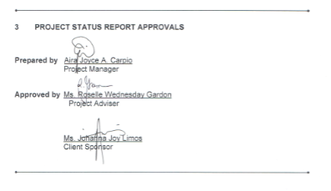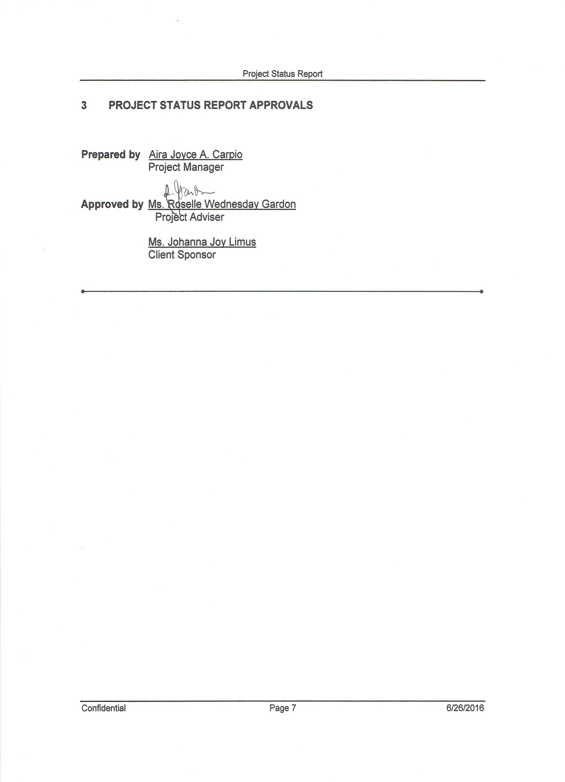



# APPENDICES

## Document Guidelines

## Project Status Report Sections Omitted

